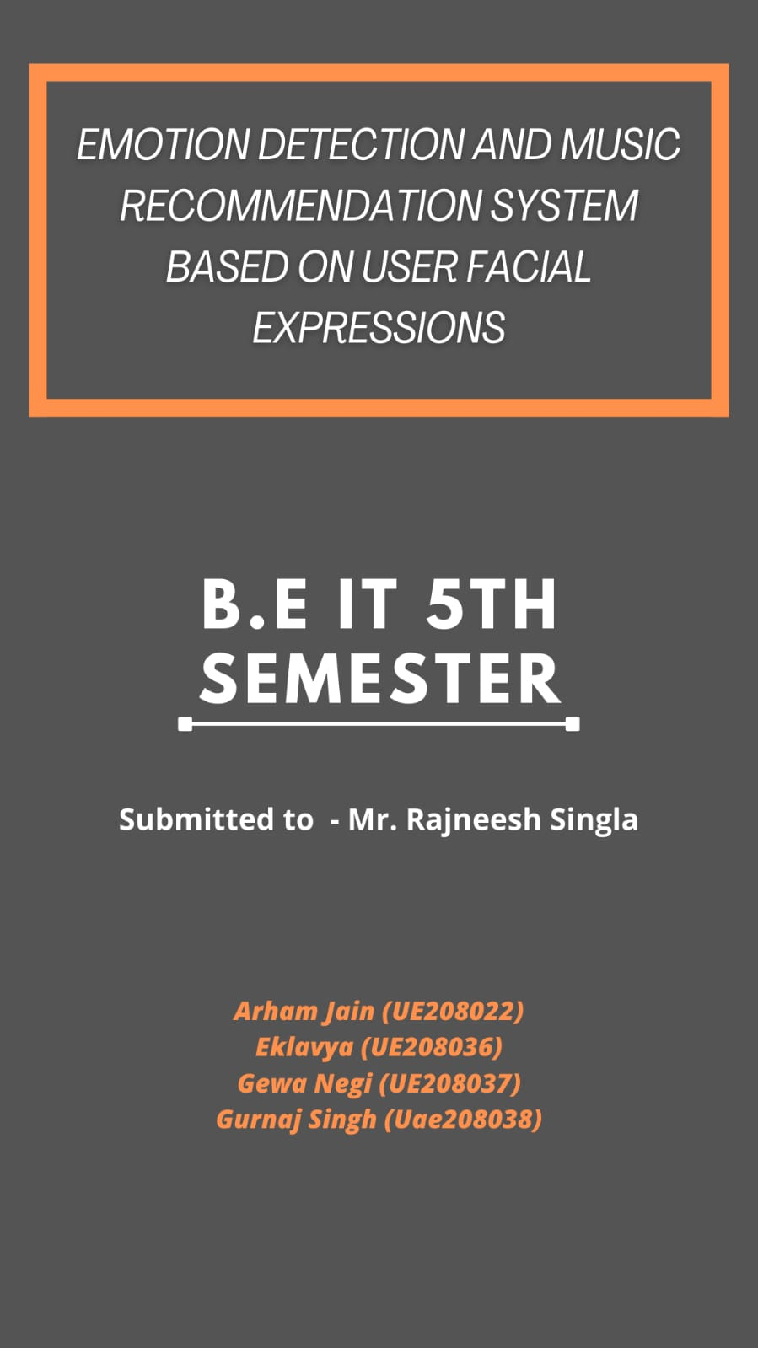

**Table of Contents**

**Chapter-1_ _ _ _ _ _ _ _ _ _ _ _ _ _ _ 4-5**

* **Idea / Motivation_ _ _ _ _ _ _ _ _ _ _ _ _ _ _ _ _ __ _ 4**
* **Introduction _ _ _ _ _ _ _ __ _ _ _ _ _ _ _ _ _ _ _ _ _ _ 5**
* ***Issues / Challenges _ _ _ _ _ _ _ _ _ _ _ _ _ _ _ _ _ _ _ 5***

**Chapter-2_ _ _ _ _ _ _ _ _ _ _ _ _ _ _ 6-7**

* **Objectives _ _ _ _ _ _ _ _ _ _ _ _ _ _ _ _ _ _ 6**
* **Modules _ _ _ _ _ _ _ _ _ _ _ _ _ _ _ _ _ _ _ 6**
* **Scope _ _ _ _ _ _ _ _ _ _ _ _ _ _ _ _ _ _ _ _ _7**

**Chapter-3_ _ _ _ _ _ _ _ _ _ _ _ _ _ _ 8-9**

* **Data Sources _ _ _ _ _ _ _ _ _ _ _ _ _ _ _ _ 8**
* **Tech Stack _ _ _ _ _ _ _ _ _ _ _ _ _ _ _ _ _ 8**
* **Methodology _ _ _ _ _ _ _ _ _ _ _ _ _ _ _ 9**

**Chapter-4_ _ _ _ _ _ _ _ _ _ _ _ _ _ _ 10-11**

* **Work Plan _ _ _ _ _ _ _ _ _ _ _ _ _ _ _ 10**
* **Bibliography _ _ _ _ _ _ _ _ _ _ _ _ _ _ _ 10-11**

**Acknowledgement**

Whenever a module of work is completed successfully , a source of motivation and guidance is always there for student . This Project is Golden Opportunity for learning about upcoming new Technologies and Self Development . We hereby take the opportunity to thank all the wonderful people who provided this golden opportunity to us .

We would like to express our gratitude towards our respected **Mr. Rajneesh Sigla Sir** ***(Project Mentor)*** , for the guidance and help we received from him during this *Project Report .* We as a team are highly obliged and appreciate him for his timely help and guidance .

**Chapter-1**

**------Problem Title------**

Emotional Detection and Music Recommendation System based on User Facial Expression

**------Introduction to the Problem------**

**Idea / Motivation**

* It is well known that humans make use of facial expressions to express more clearly what they want to say and the context in which they meant their words.
* The main objective of our music recommendation system is to provide suggestions to the users that fit the user’s preferences.
* The analysis of the facial expression/user emotion may lead to understanding the current emotional or mental state of the user.
* Therefore by developing a recommendation system, it could assist a user to make a decision regarding which music one should listen to helping the user to reduce his/her stress levels.

**Introduction**

* The project aims to capture the emotion expressed by a person through facial expressions.
* The user would not have to waste any time in searching or to look up for songs and the best track matching the user’s mood is detected, and songs would be shown to the user according to his/her mood.
* A music player is designed to capture human emotion through the web camera interface available on computing systems.
* The software captures the image of the user and then with the help of image segmentation and image processing techniques extracts features from the face of a target human being and tries to detect the emotion that the person is trying to express.
* The project aims to lighten the mood of the user, by playing songs that match the requirements of the user by capturing the image of the user.

**-----Issues / Challenges in current scenario** -----

1) Accuracy :

2) Data set

3) Identifying facial features.

4) Songs personalization.

5) Underlying hardware Requirements.

6)Identifying Children’s emotion.

7)Cultural difference in emotional expression.

8)Psychological Challenges.

**--------Chapter-2--------**

*Objectives covering the innovation aspect :*

* **PROJECT OBJECTIVE:**

The main objective of this project is to develop the “Emotion Based Music Player” for all kinds of music lovers which aimed to serve as a platform to assist individuals to play and listen to the songs according to his emotions. It is aimed to provide a better enjoyment of entertainment to the music lovers.

* **Specific Objective:**

The Specific Objective for this project is specified as below:

i. To propose a facial expression detection model to detect and analyze the emotion of an individual.

ii. To accurately detect the four basic emotions, namely normal, happy, sad and surprise.

iii. To integrate the music player into the proposed model to play the music based on the emotions detected.

iv. To keep track individual’s mood and help them improving Mental Health.

----------Modules----------

1) Face detection

2) Face recognition

3)Feature Extraction

3) Emotion detection

4) Songs recommendation and personalization

----------Scope Of this Project ----------

This project can be used in two ways :

Method-1) **Music Recommendation App**: Nowadays, music platforms provide easy access to large amounts of music. They are working continuously to improve music organization and search management thereby addressing the problem of choice and simplify exploring new music pieces. Recommendation systems gain more and more popularity and help people to select appropriate music for all occasions. However, there is still a gap in personalization and emotions driven recommendations. Music has a great influence on humans and is widely used for relaxing, mood regulation, destruction from stress and diseases, to maintain mental and physical work.

Method-2)**Mood Tracker App** : We can keep track of persons moods by maintaining data of facial expressions . Thus we can tracks person’s mental health and can improve person’s mental health . Also Research shows that mood tracker apps can help people better identify their moods and, in turn, understand them. Awareness of one’s mood has been linked to better mental health outcomes. Additionally, apps can help people better communicate with mental health professionals by recording the data that someone can refer back to during an appointment.

Music is a powerful language to express our feelings and in many cases

is used as a therapy to deal with tough moments in our lives. Emotions

and moods can be easily reflected in music, when we are doing sports,

we tend to listen to energetic music, similarly when we are anxious or

tired a nice relaxed song can help us to calm down.

Music is a powerful language to express our feelings and in many cases

is used as a therapy to deal with tough moments in our lives. Emotions

and moods can be easily reflected in music, when we are doing sports,

we tend to listen to energetic music, similarly when we are anxious or

tired a nice relaxed song can help us to calm down.

Music is a powerful language to express our feelings and in many cases

is used as a therapy to deal with tough moments in our lives. Emotions

and moods can be easily reflected in music, when we are doing sports,

we tend to listen to energetic music, similarly when we are anxious or

tired a nice relaxed song can help us to calm down.

Music is a powerful language to express our feelings and in many cases

is used as a therapy to deal with tough moments in our lives. Emotions

and moods can be easily reflected in music, when we are doing sports,

we tend to listen to energetic music, similarly when we are anxious or

tired a nice relaxed song can help us to calm down.

Music is a powerful language to express our feelings and in many cases

is used as a therapy to deal with tough moments in our lives. Emotions

and moods can be easily reflected in music, when we are doing sports,

we tend to listen to energetic music, similarly when we are anxious or

tired a nice relaxed song can help us to calm down.

**-----------Chapter-3-----------**

*Data Sources :*

*Most public Datasets available are not sufficient . They are not diverse enough in terms of gender and race and contains limited sets of emotional expressions.*

*But there are three ways to overcome this issue :*

*1) Create our own Dataset .*

*2) Combine Several Datasets.*

*3) Modify the Data as we proceed.*

*Some previous Data Set Collection :*

*Kaggle Data Set for facial Detection Link:* [*https://www.kaggle.com/c/challenges-in-representation-learning-facial-expression-recognition-challenge/data*](https://www.kaggle.com/c/challenges-in-representation-learning-facial-expression-recognition-challenge/data)

**HELEN Dataset Link** - The dataset contains around 200 images are used for the training of the classifier. Along with the images, 164 landmarks positions are provided for each and every image present in the dataset in the form of a .txt file. These coordinates are extracted from the text files and used in the system to generate the .xml file. This XML file is further used to train the classifier. This trained classifier is used to predict the position of the landmarks in the other set of unknown images.

Link : <https://www.kaggle.com/c/challenges-in-representation-learning-facial-expression-recognition-challenge/data?select=test.csv>

----------Technology Stack :----------

For App Designing :

* HTML/CSS - Frontend styling and web page design.
* Java-script - Frontend music player functions.
* Django - Backend integration of machine learning algorithms.

For Model Training :

* Python
* Artificial intelligence
* Open CV
* Colab / Tenserflow
* CNN

------------Methodology-----------

* **Face Detection**
* **Emotion Detection**
* **Music Recommendation**
* **Integration**

**----------Conclusion----------**

* A project on Firebase will be created and mp3 songs will get uploaded in the storage section. These songs as per mood and language in the real time database section. After this, the Firebase database will get linked to Android studio. An appropriate UI for the android application will be created and the tflite model methods will get linked with the songs on Firebase. Finally, the application will be tested to fix the bugs if any.

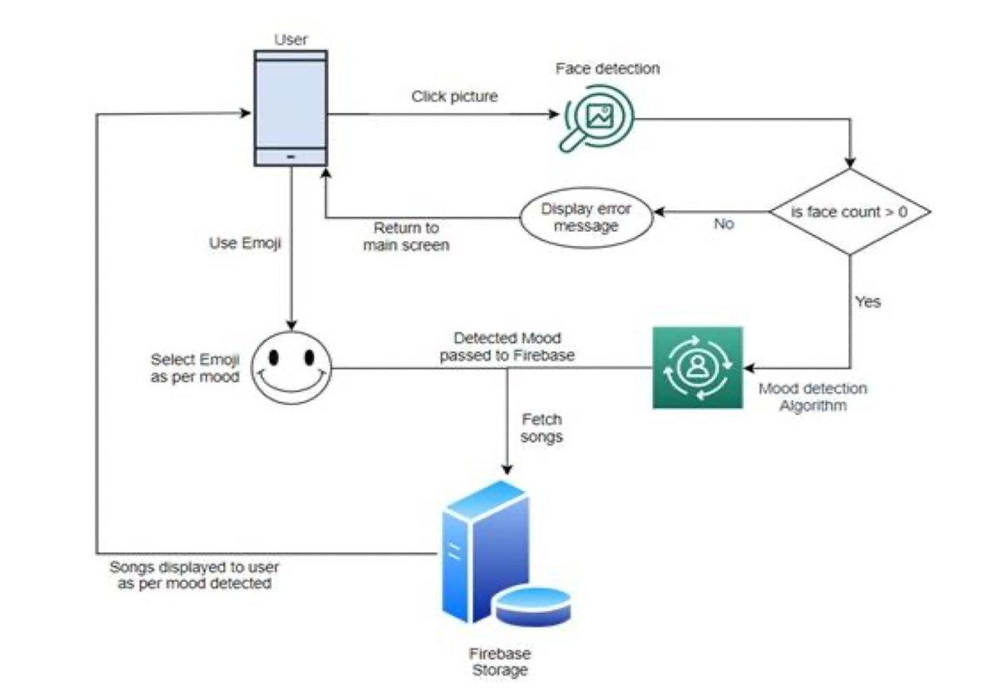

*Proposed/ Raw System Architecture Diagram*

***----------Chapter-4--------***

***Work Plan***

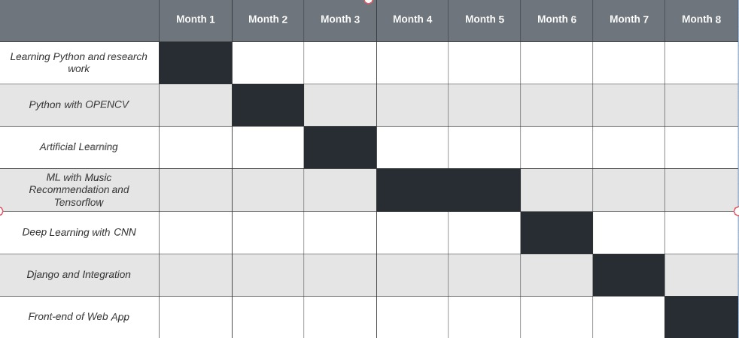

***Bibliography :***

***[1] Yash Bagadia, Parul Tambe, Noorulain S.Haikh, Tahir Khalil, Prof. L.J. Sankpal (2016) : Advanced Music Player With Integrated Face Recognition***

***Mechanism : INTERNATIONAL JOURNAL OF INNOVATIVE RESEARCH IN TECHNOLOGY(IJIRT) | Vol.3***

***[2] G.Hemalatha, C.P. Sumathi (2014) : A Study of Techniques for Facial Detection and Expression Classification : INTERNATIONAL JOURNAL of COMPUTER SCIENCE & ENGINEERING SURVEY (IJCSES) | Vol.5 No.2***

***[3] Madhuri Athavle, Deepali Mudale, Upasana Shrivastav, Megha Gupta (2021) : Music Recommendation Based on Face***

***Emotion Recognition : JOURNAL of INFORMATICS ELECTRICAL and ELECTRONICS ENGINEERING (JIEEE)***

***[4] Ankita Mahadik, Prof. Vijaya Bharathi Jagan, Shambhavi Milgir, Janvi Patel (2021) : Mood based Music Recommendation System : INTERNATIONAL JOURNAL of ENGINEERING RESEARCH and TECHNOLOGY (IJERT) | Vol.10***

***[5] Puri, Raghav & Gupta, Archit & Sikri, Manas & Tiwari, Mohit & Pathak, Nitish & Goel, Shivendra (2020) : Emotion Detection using Image Processing in Python***

***[6] Wafa Mellouka, Wahida Handouzia (2020) : Facial emotion recognition using deep learning : The 2nd International Workshop on the Future of Internet of Everything (FIoE)***

***August 9-12, 2020, Leuven, Belgium***

***Further References :***

***[1] https://www.apriorit.com/dev-blog/642-ai-emotion-recognition***

***[2]https://www.researchgate.net/publication/351720842_Emotion_Based_Smart_Music_Player***

***[3] https://iopscience.iop.org/article/10.1088/1742-6596/1755/1/012006/pdf***

***[4] https://www.analyticsvidhya.com/blog/2021/11/build-face-recognition-attendance-system-using-python/***

***[5] https://www.ijert.org/mood-based-music-recommendation-system***